VIDEOJET TECHNOLOGIES INC.

SUPPLIER GUIDE TO

iSupplier Portal
Table of Contents

Topic | Page
Introduction | 3
Where do I Start? | 5
How do I navigate the iSupplier Home page? | 6
What’s under the Tabs? | 7
ORDERS | 7
Acknowledging Purchase Orders | 8
Submitting Change Requests | 10
Splitting Shipments | 11
SHIPMENTS | 14
Use Delivery Schedules to view open Purchase Order shipments | 14
Creating an Advance Shipment Notice | 16
Overdue Receipts | 19
PLANNING | 21
PRODUCT | 21
ACCOUNT | 22
Viewing Invoice Information | 22
Other General Questions | 23
What are notifications? | 23
How do I manage iSupplier Portal notifications? | 23
Additional Help | 23

Oracle iSupplier Portal is a collaborative application that enables buying companies and their suppliers to communicate with each other. It enables suppliers to have real-time access to information (such as purchase orders and delivery schedules) and respond to the buying company with order acknowledgments, change requests, shipment notices, and planning details. It also allows buying organizations to search for order, shipment, receipt, invoice, and payment information across all suppliers and all business units, as well as respond to supplier change requests.

PC Requirements

A personal computer with at least a 486 processor and 128K of RAM is required. An internet connection of at least 56K BPS is recommended. Required software includes Adobe Acrobat reader (download free at http://www.adobe.com/products/acrobat/readstep2.html), Microsoft Excel, and Microsoft Internet Explorer 5.5 or higher (download free at www.microsoft.com/ie).

Accessing Videojet’s iSupplier Portal

The Portal is accessed simply by going to the appropriate URL (web address).
- Enter your username and password on the left hand side of this url: http://supplier.videojet.com/. This link also has other helpful iSupplier Portal information such as availability of iSupplier Portal, Videojet’s holiday schedule and manual of iSupplier Portal.
- OR access iSupplier Portal directly through

https://ipartner.videojet.com/OA_HTML/AppsLogin

Login Page should appear:

Login Credentials
To access Videojet’s iSupplier Portal, you will need to receive a registration email from a Buyer at Videojet.
Where Do I Start?

Setting Up User Preferences
You can change your user settings or preferences at any time using the Preferences icon. You can change the following preferences:
- General - You can select your language, territory, time zone, client character encoding (the character set that's used in your page display), and accessibility features (such as screen reader use).
Note: Date and time values are always displayed to you in the time zone you set in your user preferences, even if your buying company is in a different time zone.
- Notification - You can select how you want to receive your notifications (for example, in HTML or plain text e-mail).
- Formatting - You can define your date format and number format.
- Password - You can reset or change your password. A valid password must be at least six, but no more than 30, characters. Passwords can be numeric, alphanumeric, or special characters. The new password will be effective immediately.
How do I navigate the iSupplier Home page?
The iSupplier Home page is laid out to help you find the information you need quickly and easily. A good way to start is by using the tabs along the top right. For example, if you want to view details of or accept a purchase order start by clicking the Orders tab. This action then presents you with a task bar with various tasks starting on the left in a line below the tab you just selected.
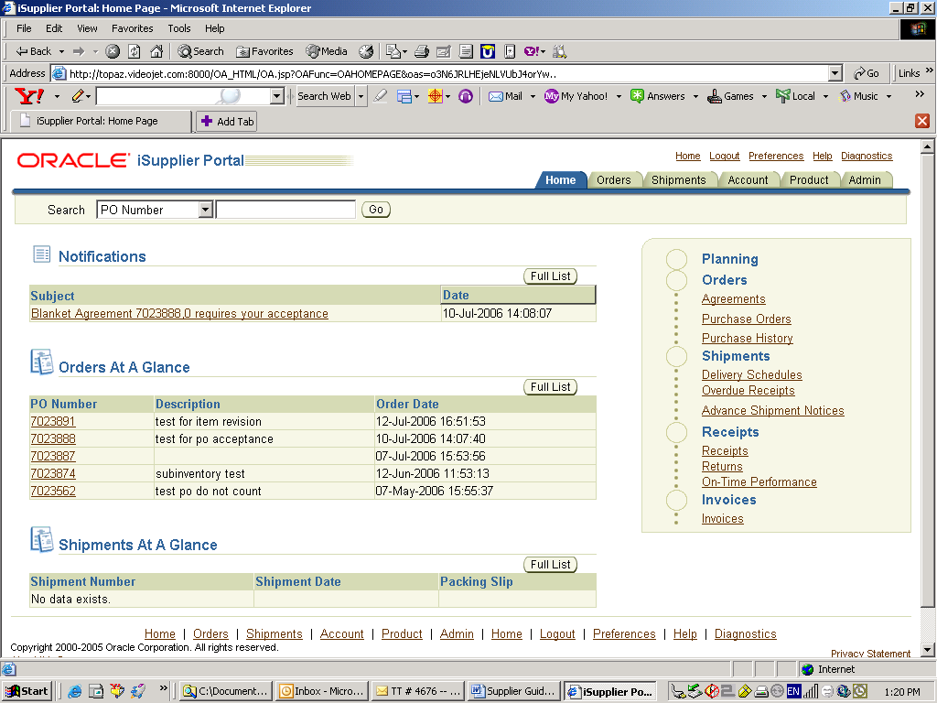
Once you are familiar with our titles for various combinations of information you can save some time by simply clicking the linked name of the inquiry which is listed down the right edge of the iSupplier Home page. These are grouped in a Procure-To-Pay style road map.
The middle portion of the iSupplier Home page is reserved for:
- Notifications that are waiting for you to review. To review your notifications click the linked Subject
- Your most recent orders. Click the "PO Number" link to view details of a recent order placed with you.
- A list of your most recent shipments. To review the details of recent shipments click the "Shipment Number" link.
Click More on each list to view a full page window.
On the top left edge of the iSupplier Home page is a quick search box so you can search for Purchase Orders. If you know the number that you need details for, simply enter it in the appropriate box, and click Go.
How do the other pages work?
Once you leave the iSupplier Home page by clicking a tab and a task, the pages have been designed to simplify viewing the information that you are interested in. On most of these pages you are expected to begin a simple search. This is done by entering or selecting some search criteria such as a purchase order number and then clicking Go (Search). Your results are returned in a list format in the lower section of the page.
What’s under the TABS?
ORDERS
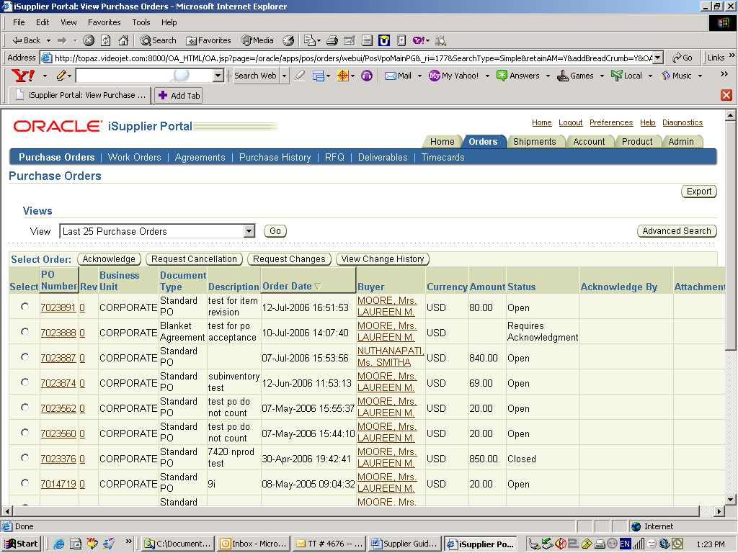
View Purchase Orders
This inquiry will allow you to view purchase order header and detail information. Optionally you can accept po’s and change shipment dates. When you go to the Purchase Order tab, the system will display the most recent 25 purchase orders placed with you. You can change the basic search criteria to view All Purchase Orders or Purchase Orders to Acknowledge. The resulting list is available to Acknowledge, Reschedule or Export.
To view purchase order header and line details, click the purchase order number and the system will drill down to the purchase order document. From the order detail page that results from your drill down; you can review receipts, invoices, and payments related to that order.

Acknowledging Purchase Orders
When creating a purchase order, buying companies can request acknowledgment of the purchase order. If so, you will receive a notification requiring your response. The purchase order may include a date by which you need to acknowledge or sign it.
You acknowledge purchase orders to communicate to the buying company that you have received, reviewed the details of, and accepted or rejected a purchase order. You can also communicate changes to the purchase order during acknowledgment.
You can either acknowledge the order online, or accept or reject the order using the notification. The notification does not allow shipment level acknowledgment, which must be entered online. When you respond, the purchase order is automatically updated, and a notice is sent to the buyer.
You can submit acknowledgments for an entire order, or for individual shipments. For example, if you can fulfill only part of a purchase order, accept the shipments you can fulfill, and reject the others. You can also communicate change requests during acknowledgment. For example, if you cannot fulfill a shipment on the given date, but can fulfill it a few days later, you can communicate a date change request instead of rejecting the shipment line.

To acknowledge purchase orders:
- Click the Orders tab, and then click Purchase Orders in the task bar below the tabs.
- Select Purchase Orders to Acknowledge, and then click Go. If you know the PO number of the purchase order you would like to acknowledge, you can use advanced search to display purchase orders.
- Select a purchase order with a status of Requires Acknowledgment, and click Acknowledge.
- On the Change Purchase Order page, you can accept or reject an entire order, or you can accept or reject individual shipments.
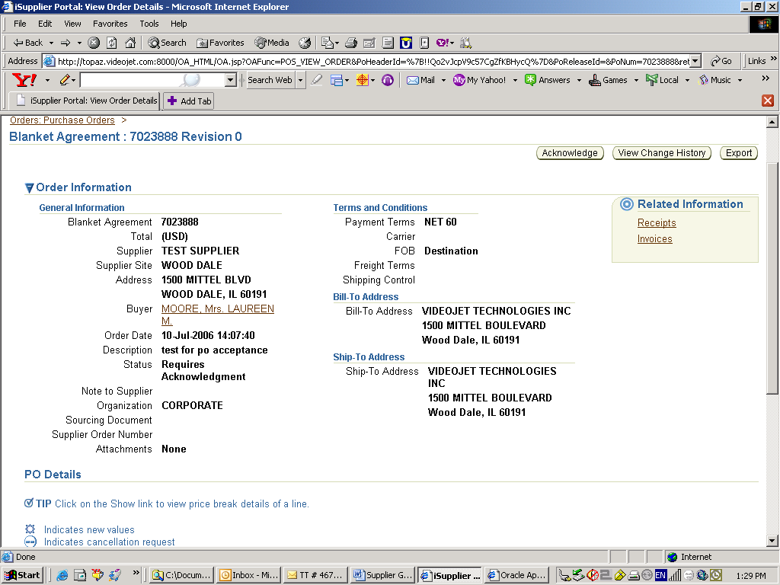
Order Level acknowledgment:
- To accept an entire order, click Accept Entire Order, enter a note to your buyer, and click Submit.
- To reject an entire order, click Reject Entire Order, enter a note to your buyer, and click Submit.
Shipment Level acknowledgment:
- To respond at a shipment level, in the PO Details section, make your changes. Enter the response reason, and click Submit. The available actions at the shipment level are Accept, Reject, and Change.
After you have completely acknowledged the order, the buyer is notified of your acknowledgment response.

Submitting Change Requests
Oracle iSupplier Portal enables you to request changes to purchase orders when modifications are needed to fulfill an order. You can make changes during and after acknowledgment.

To submit change requests:
- Click the Orders tab, and then click Purchase Orders in the task bar below the tabs.
- On the Purchase Orders page, search for and select a purchase order.
- Click Request Changes.
- On the Change Purchase Order page, enter your changes. If you would like to make changes to shipment details, click Show.
- You may request changes to:
- Price/Price Breaks on Blanket Agreements
- Supplier Item
- Quantity Ordered
- Promised Date
- Supplier Order Reference Number
- Additional Change Requests - use this text box if you would like to submit more changes than offered above. You may enter both order and line reference numbers. If you would like to split a shipment, see Splitting Shipments.
In the reason text box, you can enter a reason for your change request.
- Click the appropriate action button from the action list. Enter your reason for change, and then click Submit.
Note: After submitting your changes, the purchase order status changes to Supplier Change Pending until the buyer approves the changes.

To view change order history:
This view enables you to view the history of change requests submitted on a document, and the corresponding buyer response.
- Click the Orders tab, and then click Purchase Orders in the task bar below the tabs.
- Search for and select a purchase order, and then click View Change History.
View the change order history details on the PO Change Order History page.
- Click OK to return to the Purchase Orders page.

Splitting Shipments
You can request to split a shipment. For example, if you can only partially ship the quantity ordered for the given date, you can enter a split shipment change request. This request will let the buyer know the number of items you can deliver and what date you will deliver them.
To request to split a shipment:
- Click the Orders tab, and then click Purchase Orders in the task bar below the tabs.
- Search for and select a purchase order, and then click Request Changes.
- On the Change Purchase Order page, click Show to display shipment details.
- Click the split icon on the desired shipment line. (Another row is added for your split shipment).
- In the Quantity Ordered field of the first shipment line, enter a new quantity.
- In the Quantity Ordered field of the second shipment line, enter the new quantity.
- Change the Promised Date.
- Enter the Supplier Order Line.
- Enter a reason for splitting.
- Select an action for change.
- Click Submit.
Note: You can split a shipment as many times as needed. To create more shipment lines, click the split icon.

View Work Orders
Using work orders, buyers and suppliers can monitor outside processing from third parties whose Work In Process (WIP) status and delivery tracking information is critical to their supply chain process flow. Outside processing activities are the activities of the third-party suppliers who provide services needed to complete the final product or maintenance activity.
To view work orders, click the Orders tab, and then click Work Orders in the task bar directly below the tabs. Using the search criteria, you can view details of the orders, schedules, WIP details, operations instructions, components, and component instructions by selecting the links provided. You can also reschedule an order.
View Agreements
This inquiry provides a list of purchase agreements that you have made with the buyer's company. You can review the details of those agreements and the releases (orders) that have been created for a particular agreement. The basic search for agreements includes PO Number, Effective From, and Effective To.
To view purchase agreement header and line details; click Search and then click the PO number from the search results. The system will display the Purchase Orders Summary page. This is a list of the orders which have been created under this agreement. From this summary page you may review details of each order, view receipts against this order, or Export the summary.
View Purchase Order Revision History
The Purchase Order Revision History page enables you to search for details on the revision history of a purchase order.
Using the search criteria, you can get a summarized list of purchase orders that have been revised. You may choose to compare each revised PO to the original PO, the previous PO, or last signed PO (if the revised PO has been signed). You can also view all changes made to the PO.
View RFQ - Request for Quotations
This inquiry provides the details of all RFQs created by the buying organization in their ERP application. The basic search criteria are RFQ Number and Response Due By date. You can view all of the details of the RFQ by clicking the RFQ number, details about the company contact are available by clicking the Contact Name, and details of the Ship To Location are available by clicking the Location Code. As with many other inquiries, you can Export the summary.
Note that you can sort your search results by either RFQ Number or Response Due By date.
View Deliverables
If your buying company has implemented Oracle Procurement Contracts, you may have deliverables assigned to you. Deliverables are tasks to be completed in order to achieve a certain outcome or business objective, and may be used to track projects for compliance reasons and risk reduction.
View Timecards
To be paid for services rendered, contractors can record hours worked using timecards. You may access these time cards if the Timecards task appears under the Orders Tab. You will be able to view timecard information and check the amount of time confirmed by the hiring manager.
To view timecards, click the Orders tab, and then click Timecards in the task bar directly below the tabs. Use the search criteria to get a summarized list of timecards. Click View Timecard to get more details about the timecard. You can export details from any page.
SHIPMENTS
The information views under the Shipments tab can be utilized to view your PO shipments activity and help you plan delivery schedules
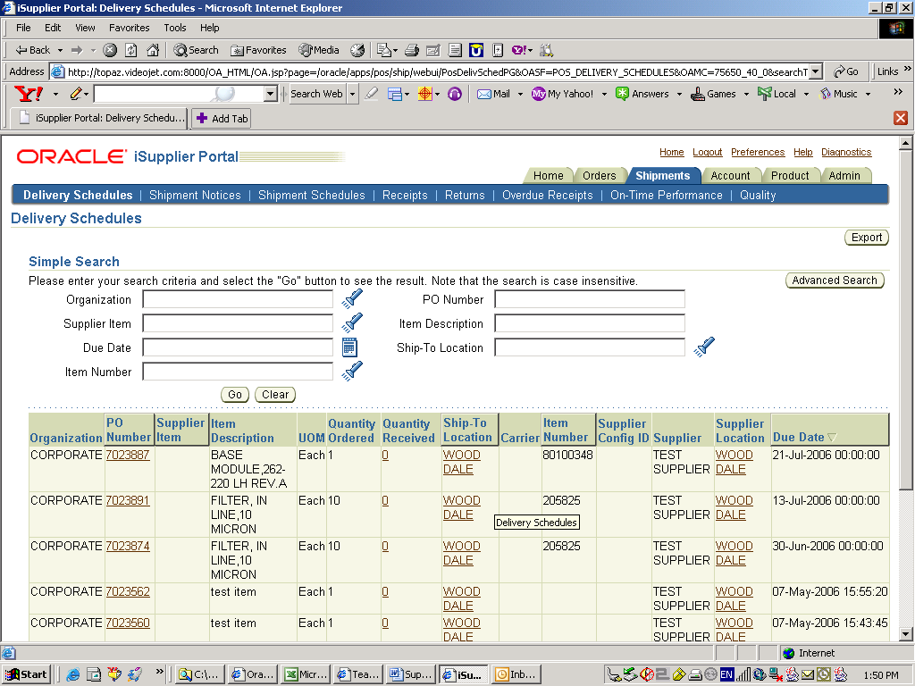
Delivery Schedules
You can use this inquiry to quickly determine deliveries that require schedules and shipments that are past due. Basic search criteria are PO Number, Supplier Item, Item Description, and Due Date. The Delivery Schedule summary that results from your search can be sorted by PO Number, Supplier Item, Due Date, and Ship-To Location. The resulting shipment details can be reviewed and Exported to schedule deliveries with more accuracy.
In addition, drill down links are provided for PO Number, receipt Quantity, and Ship-To Location should you need more detail.
Added Nov. 11, 2011
Use Delivery Schedules to view open purchase order shipments
- Click the Shipments tab and ensure that ‘Delivery Schedules’ is highlighted in the task bar below the tabs.
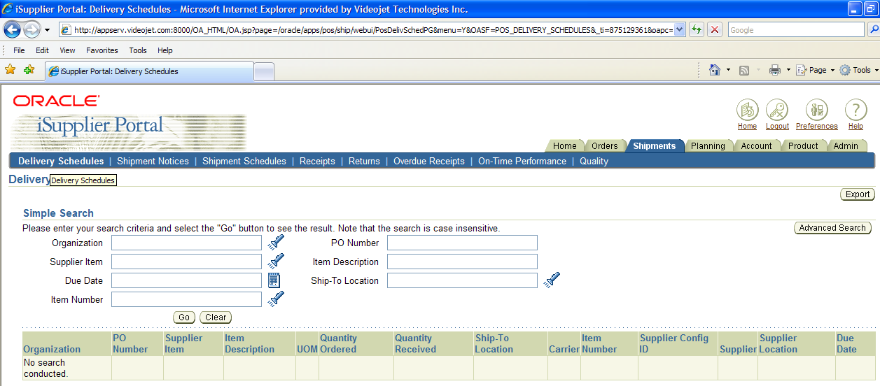
- To view all PO’s that are OPEN (awaiting receipt at Videojet), click on Go button or enter criteria in the fields above to narrow down results. Screen below will display, which lists PO’s that are not closed and awaiting receipt.
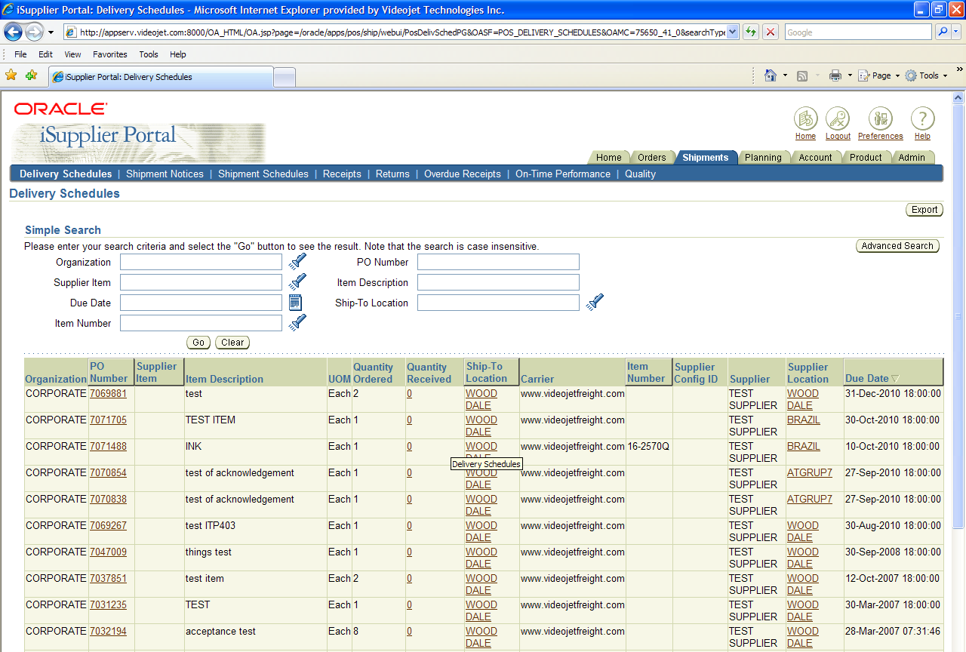
Shipment Notices
This selection leads to a choice of links:
- Create Advance Shipment Notices
- Create Advance Shipment Billing Notices
- View/Cancel Advance Shipment Notices
The Advance Shipment Notice (ASN) provides immediate visibility to supplier shipments against specified purchase orders. You can provide billing information along with the shipment notice which creates an invoice in payables.
View Advanced Shipment Notices:
After you have submitted the ASN/ASBN to the buying organization you can view the ASN/ASBN online at a later time. This enables suppliers to better manage purchasing and receiving department inquiries for shipment information.
This inquiry initial lists the last ten shipment notices but you can also choose to list all of them that you have submitted. The summary includes the status of the ASN/ASBN as well as the Shipment Number, Ship Date, Expected Receipt Date, and other details of the shipment. You can sort the summary by Shipment Number and Ship Date. Drill down links are provided for Shipment Number and Invoice Number.

To create advance shipment notices:
- Click the Shipments tab, and then click Shipment Notices in the task bar directly below the tabs.
- On the Shipment Notices page, click Create Advance Shipment Notices for an ASN or Create Advance Shipment Billing Notice for an ASBN.
Note: If you are creating an ASBN, all selected shipments must belong to the same business unit.
- Select either View Shipments Due This Week or View Shipments Due Any Time, and then click Go. Click Advanced Search to enter additional search criteria.
- Select one or multiple purchase order shipments, and then click Add to Shipment Notice.
- On the Create Advance Shipment Notice or Create Advance Shipment Billing Notice page, enter the appropriate shipment line defaults.
Note: You can always add more shipments by clicking Add Shipments on the Shipments Line page.
- You can enter the line details once for all shipment lines if the details are common to all lines. To copy all default shipment lines, click Default to All Lines.
- To split a shipment line, click the split icon in the Shipments in Advance Shipment Notice section, and enter Shipping Quantity for the original and new lines.
- To remove a shipment, click the remove icon in the Shipments in Advance Shipment Notice section.
Note: To display shipment details, click Show in the Shipment and Advance Shipment Notice section. To hide shipment details, click Hide in the Shipment and Advance Shipment Notice section.
- If you would like to enter Licence Plate Number (LPN), Lot, or Serial Information, click the LPN/LOT/serial icon.
You will be able to enter lot and serial information for shipment lines only when the item has been defined as a lot or serial controlled item. You will only be able to enter lot information if the item is lot controlled, serial information if the item is serial controlled, and both lot and serial information if your item is a lot and serial controlled.
To enter details for a lot and serial controlled item:
  - Enter lot information. If you would like to add additional lot attributes, click the lot attributes icon.
  - If you would like to enter serial details for the lot, click Show, and then enter serial information. If you would like to add additional serial attributes, click the serial attributes icon.
  - If you have more than one lot or serial controlled item, click Add Another Row.
  - If you have LPNs nested within each other, enter nesting details in the License Plate Configuration Details section.
Note: You may change the total shipment quantity on the LPN/Lot/Serial Detail page. The total shipment quantity entered should be equal to the total lot/serial quantity.
  - When you are finished entering your LPN/Lot/Serial details, click OK.
- Click Shipment Headers. Enter the required ASN or ASBN information.
You can also enter other information. The information you enter at the header level is transferred to the line level. (However, changes you make at the line level override information at the header level).
If you are entering an ASBN, you must enter the following billing information:
  - Invoice number
  - Invoice date
  - Invoice amount
In the Remit-To site section, verify that the Remit To Site details are correct. If the Remit to Site details need to be changed, click Change, select the correct Remit To Site details, and then click Apply.
- To preview the ASN or ASBN, click Preview.
- Review the ASN or ASBN and click Submit.

Shipment Schedules
This inquiry allows you to view the details of shipment schedule lines.
Receipts
This inquiry enables you to explore a historical view of all receipts that have been recorded for the goods that have been shipped. Search criteria is provided for:
- Receipt Number
- Receipt Date
- PO Number
- Supplier Item
- Receipt Location
You can then sort your search results by Receipt Number, Receipt Date, and PO Number. Links to drill down to details of the Receipt Number and PO Number are also provided here.
Returns
Select Returns to view the return history, the causes for goods returned by the buying organization, and inspection results of a shipment. Search criteria is provided for:
- Receipt Number
- PO Number
- Shipment Number
- RMA Number
- Supplier Item
- Item Description
The search summary results includes all of the above along with details about the return such as quantities and reason for return. These results can be sorted by Receipt Number, PO Number, Shipment Number, RMA Number, and Receipt Date. This summary can then be Exported. Details of the receipt and PO can be viewed by way of drill down links.
Overdue Receipts
This inquiry enables you to view the details of purchase order shipments that are past due. The basic search criteria of PO Number, Supplier Item, or Due Date enables you to quickly find those Overdue Receipts that you are concerned about. You can then sort those search results by PO Number, Supplier Item, Due Date, or Ship-To Location and Export them. Drill down links are available for PO Number, Ship-To Location, and Buyer.
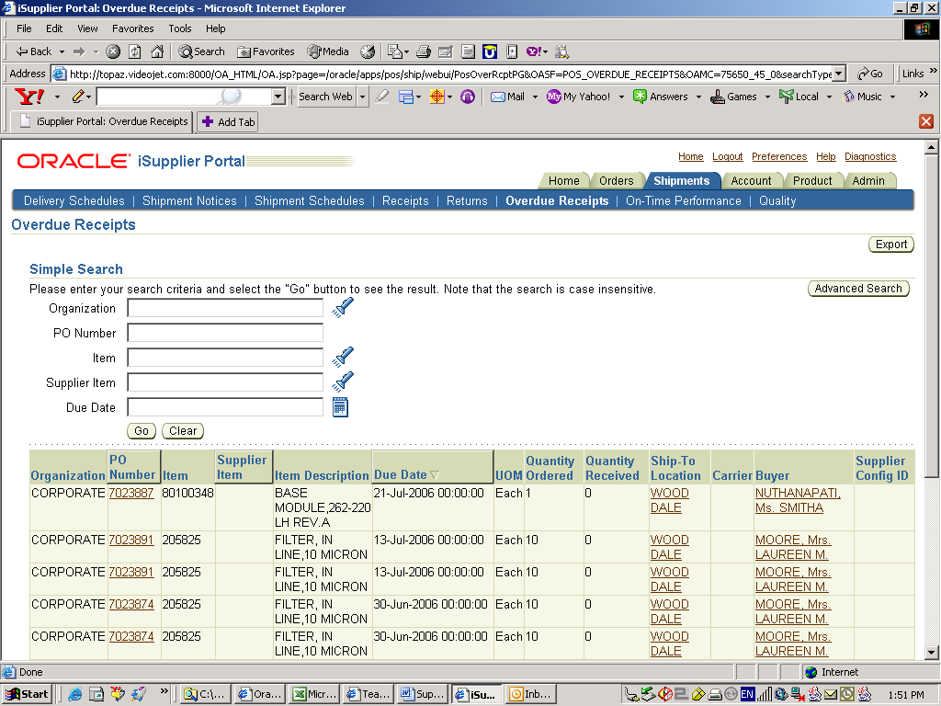
On-Time Delivery Performance
This inquiry provides the delivery status of shipments you have made against purchase orders. You can view your performance for timeliness of deliveries. Search criteria is provided for:
- PO Number
- Due Date
- Shipment Number
- Receipt
- Waybill Number
- Delivery Status
The search results include receipt and shipment information such as due and receipt dates, shipment and waybill numbers, carrier, and status. These results can then be sorted by Description and Quantity. The final results can then be Exported. You can use the drill down links to view additional details about the PO and Receipt numbers.
Quality
View and enter quality details regarding your shipments. You can search for shipment information using:
- PO Number
- Shipment Number
- Supplier Item
- Item
Links to detailed information about the purchase order and quality plans are available from the PO Number and Quality Plan columns of your search results.
PLANNING
Oracle iSupplier Portal enables you to view demand forecasts from the buying company. Using your item number, you can view different transactions. Oracle iSupplier Portal enables you to perform vendor managed inventory or track consigned inventory stock. You also can maintain your orders and capacity information on the system.

PRODUCT
Supplier Item Summary
This single inquiry is a common page that enables you to view all of the details of the products that you supply. The basic search enables you to search by Supplier Item number, Company Item number, and by Item Description. The built in sort columns are Item Description and UOM. You can view your search results in a summary format with links on each line for:
- Orders
A summary of order lines placed with you for this item. This summary includes quantity ordered, quantity received, quantity invoiced, and price break information. This list can be sorted by PO Number, Line, Item, and Supplier Item. Drill down links are provided for PO number, Ship-To Location, and Buyer.
- Overdue
This is a summary of overdue receipts for the selected item. You can sort this list by PO Number, Supplier Item, Due Date, and Ship-To Location. Drill down links are provided for PO and Receipt numbers.
- Receipt History
A summary of receipts for the selected item. This list can be sorted by Receipt Number, Receipt Date, and PO number. Drill down links are provided for PO and Receipt numbers.
- Defects
View a summary of Failed Inspection Items.
- Returns
This selection presents a Returns summary for this item that includes shipment information, RMA number, and quantities involved. You can sort by Receipt Number, PO Number, Shipment Number, RMA Number, and Receipt Date. Drill down links are provided for Receipt and PO numbers.
- On-Time Performance
View a summary of receipts for this item that includes Due Dates, Receipt Dates, and shipping information. This list can be sorted by Description and Quantity Received. Drill down links are provided for PO and Receipt numbers.
- Inventory
The On-Hand page provides more details about the item, the on-hand quantity, and links to both Revision history and Subinventory breakdown of the on-hand quantity (with Locator, Lot, and Serial).
Most of the summaries resulting from the above selection are available to Export
Quality
Suppliers can enter and view the details of the quality plans associated by the buying organization to the purchase orders. Here the basic search criteria is PO Number, Shipment Number, Supplier Item, and Item. The resulting summary includes details about the order, shipment, and quality plans. Links to drill down to more details are provided for PO Number and Quality Plan.

ACCOUNT
You can access invoice and payment information as well as review invoice status online using Oracle iSupplier Portal. If the buying company uses Oracle Payables, you can also submit invoices online.

Viewing Invoice Information
The Invoice Summary Results page enables you to view the history of all your invoices by the buying company. You can search using various search criteria such as:
- Invoice Number
- Invoice date
- Due date
- Payment status
You can select and view further purchase order details. The system displays a list of all purchase orders that are included on the invoice. You can also select and view payment details, as well as view invoice attachments. To view invoice attachments, click the attachment icon.
Note: If you submitted your invoice online, there may be a delay before you can review it because the Accounts Payable department needs to process it first.
OTHER GENERAL QUESTIONS:
What are notifications?
Notifications are messages waiting for your review. To review your notifications click the linked notification subject line and a window opens with details of your notification message.
For example, an order may be waiting for you to acknowledge (accept) it. This shows in your list of notifications as PO Number 123 requires your acceptance. Click the Subject title link and the Notification Details page opens. This page provides additional details about the order. Near the bottom of the page are the action buttons (like Accept or Reject).
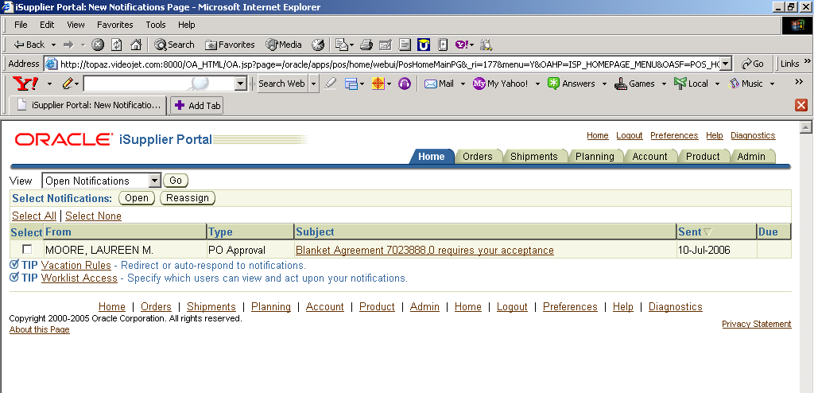
Once you have selected an action the Notifications page displays:
- You can continue to respond to any additional notifications you have.
- You can continue working by clicking the Home tab for the Home page or any of the other tabs (Orders, Shipments, Planning, Account, or Product).
How do I manage iSupplier Portal notifications?
See page 5 on how to manage your email notifications.
For additional help, please contact your Buyer.

